Creating Your Own HTML Help File

The HTML Help format (files with a .chm file extension) is a handy way to package up and share scripts. Of course, the Scripting Guys have already done this for you, haven’t we? Didn’t we create a .chm file that includes all the VBScript scripts found in the Script Center?

Yes, we did. And if that .chm file suits your needs, then there’s no reason for you to create and compile your own help file. On the other hand, maybe the .chm file that we made available has a bunch of scripts you don’t really care about; after all, if you aren’t running IIS 6.0 then you might not want a couple hundred IIS 6.0 scripts in your help file. Likewise, maybe the .chm file we made available is missing some scripts that you would find useful; for example, it’s more than likely none of the scripts you or others in your organization wrote are going to be found there. Wouldn’t it be nice to have a help file that featured not only the Script Center scripts, but the scripts that you write (and use) as well? Of course it would be. But those lazy, good-for-nothing Scripting Guys aren’t going to create a custom help file for you; the best you’ll get out of us are some instructions and scripts that will help you create such a file yourself. And that’s exactly what this document will do: it will tell you how you can create a customized .chm file all your own.

Note. Before you can create your own HTML Help file, you must download and install a copy of the HTML Workshop. You can obtain the latest version of the HTML Workshop – and its accompanying documentation – from the Microsoft Downloads Center.

Preliminary Steps

Do the following before you try to create and compile your own help file. (Hey, trust us; we wouldn’t tell you to do these things if they weren’t necessary!)

- Make sure the following files are all located in the same folder somewhere on your hard disk (it doesn’t matter which folder, just as long as they’re all in the same spot):

  - HTML_Folder_Maker.vbs
  - HTML_Page_Maker.vbs
  - HTML_File_List_HHP_Maker.vbs
  - HTML_Table_of_Contents_Maker.vbs
  - Script_Center_2.mdb

Ok, we knew you were going to ask that. Some of you might want to store the Access database (Script_Center_2.mdb) in a different folder; for example, you might want to have the scripts stored locally on your hard drive, but have the database stored in a shared folder where other people can access it. Can you do that? Sure. However, you’ll have to edit each of the .vbs files and look for this code:

objConnection.Open _
"Provider= Microsoft.Jet.OLEDB.4.0; " & _
"Data Source=script_center_2.mdb"

You’ll need to replace script_center_2.mdb with the appropriate path. Note that if your path includes spaces, this can get a bit tricky. Here’s an easy to get around that problem:

strPath = "C:\Public\Administrative Scripts\script_center_2.mdb"

objConnection.Open "Provider=Microsoft.Jet.OLEDB.4.0;" & _
"Data Source=" & strPath
- Create a folder named C:\HTML; this is the default folder used by the Do-It-Yourself Kit scripts when creating an HTML Help file. Note that you don’t have to use this folder; you can store your files in any folder you want to. However, the path C:\HTML has been hard-coded into the four scripts used to create an HTML Help file. If you want to use a folder other than C:\HTML, open each of these four files, find the path C:\HTML, and change it to the appropriate folder path:

  - HTML_Folder_Maker.vbs
  - HTML_Page_Maker.vbs
  - HTML_File_List_HHP_Maker.vbs
  - HTML_Table_of_Contents_Maker.vbs
- Copy the files Default.htm and Icon.jpg. These are the default files used to create the home page for the Portable Script Repository. In case you’re wondering, the page itself looks like this:

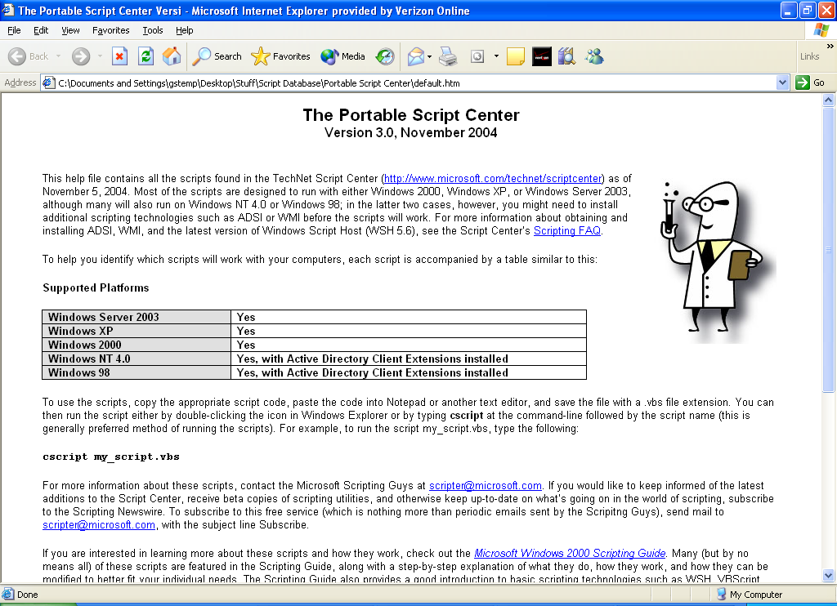

Now, you might very well be saying, “Wait a second, I don’t want to use your home page; I want to use my own home page.” Hey, take it easy: that’s perfectly fine with us. In that case, the easiest way to do this is to create your own home page, name it default.htm, and then copy that and any accompanying files (such as graphics) to C:\HTML. And if you really want to do this yourself, and don’t want to name your file default.htm, well, even that’s OK. Just open these two scripts, search for default.htm, and then replace default.htm with the name of your file:

  - HTML_File_List_HHP_Maker.vbs
  - HTML_Table_of_Contents_Maker.vbs
But, really, it would be a lot easier just to name your file default.htm. And if anyone asks, we promise to tell them that no, Microsoft didn’t force you to use that file name, you chose it on your own.

- If you want to create an HTML Help file that includes all the scripts found in the database, then you’re ready to begin. However, what if you want to create a customized HTML Help file, one that includes only a subset of the scripts found in the database? Well, in that case, you have at least two options.

First, you can simply remove the scripts that you don’t want; as a result, the database will include only the scripts that you want to show up in the help file. This isn’t the most high-tech and sophisticated approach in the world, but it’s definitely fast, and it will definitely work. To do this, make a copy of Script_Center_2.mdb, and save that copy somewhere safe. (That way, you’ll always have a version of the database that contains all the scripts.) Open Script_Center_2.mdb in Microsoft Access, open the Scripts table, and then delete the scripts you don’t want. (Or, if you’re comfortable working with Access, write a query that will delete the scripts you don’t want.) Upon finishing, you’ll have a database containing only a subset of scripts, and you can run the .vbs files against that database without having to change the .vbs files in any way.

Now, the preceding approach will work just fine; on top of that, it’s both quick and easy. However, it’s not very flashy; if you’re trying to impress someone, the old-fashioned method of deleting records from a database won’t suffice. Therefore, a second way to create a custom help file is to modify the queries that extract records from the database. To do this, you’ll need to open each of the .vbs files and look for SQL queries similar to this:

objRecordSet.Open "SELECT * FROM Scripts WHERE ScriptLanguage = 'VBScript' ORDER BY Path", objConnection, adOpenStatic, adLockOptimistic

What you will need to do is modify the WHERE clause to specify which files should be created and added to the help file. For example, suppose you wanted to create a help file consisting only of Perl scripts. In that case, the actual SQL query would look like this:

"SELECT * FROM Scripts WHERE ScriptLanguage = 'Perl' ORDER BY Path"

What if you wanted only VBScript scripts that work on Windows NT 4.0? In that case, your query would look like this:

"SELECT * FROM Scripts WHERE ScriptLanguage = 'VBScript' AND WinNT = 'Yes' ORDER BY Path"

How about a .chm file consisting only of IIS 6.0 scripts:

"SELECT * FROM Scripts WHERE ScriptLanguage = 'VBScript' AND Category2 = 'IIS 6.0' ORDER BY Path"

You get the idea. Take a look at both the database and the Database Description document, and have at it. Remember: you’ll need to modify each of the .vbs files to ensure that everything works correctly.

- Step 5 is optional, but we know it will come up: what if you don’t like the look of the HTML pages? By default, this is what the HTML pages look like when you generate them using HTML_Page_Maker.vbs:

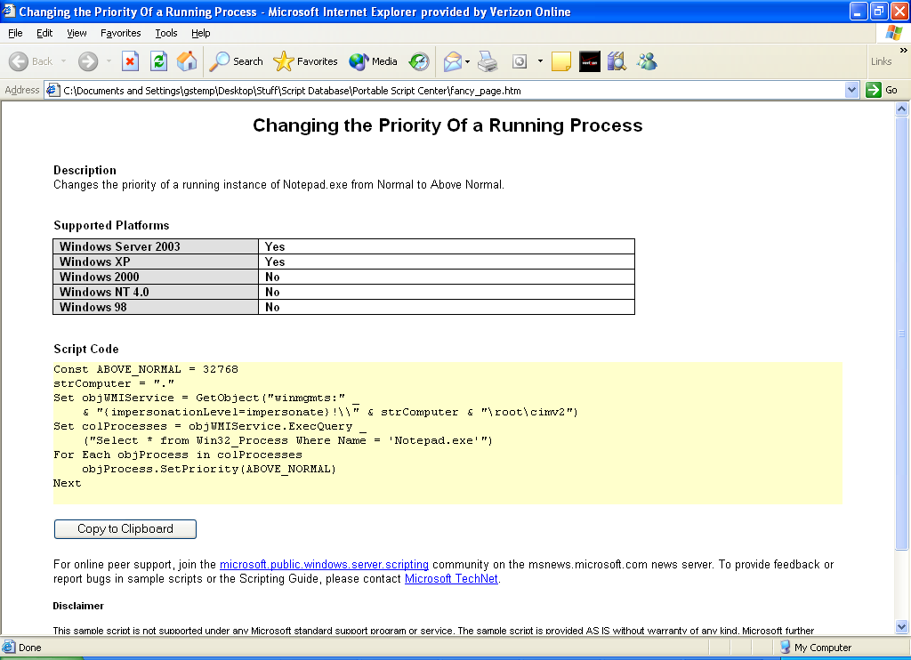

Sure, we think they’re a work of sheer beauty, but there’s no accounting for taste, right? If you want your pages to have a different look and feel, you’ll need to modify the script HTML_Page_Maker.vbs. This is not necessarily hard to do, but it can be a bit tricky; on top of that, you’ll need to know not only a little something about VBScript, but also a little something about HTML. However, it’s not impossible.

For example, suppose you want to change the background color from white to a light blue. That’s a fairly easy one; just open HTML_Page_Maker.vbs and look for this line of code:

NewFile.WriteLine "<body>"

As you can probably tell, this line of code writes a simple body tag to the HTML file; in other words:

<body>

To have a light blue background, you need this body tag instead:

<body bgcolor="#A0C5D6">

Consequently, you’ll need to change the code NewFile.WriteLine "<body>" so that it writes this new body tag. This ought to do the trick:

NewFile.WriteLine "<body=" & chr(34) & "#A0C5D6" & chr(34) & ">"

Yes, it looks weird, but that’s because we have to embed double quotes in the string (that’s what chr(34) does). We’re not saying it’s the most fun you’ll ever have, but it can be done.

Or perhaps you’d like to stick your corporate logo on the top of each page. Here’s the HTML code for that (assuming your corporate logo is named icon.jpg):

<img border="0" src="icon.jpg" width="158" height="211"><p>

To get the script to write this HTML code, you’ll need to do something similar to this:

NewFile.WriteLine "<img border=" & chr(34) & "0" & chr(34) & "src=" & chr(34) & "icon.jpg" & chr(34) & " width=" & chr(34) & "158" & chr(34) & " height=" & chr(34) & "211" & chr(34) & "><p>"

Again, the key is to use chr(34) to insert double quotes any place they’re needed. Or, just copy the above, paste it in, and change the parameter values as needed.

Note. Aren’t there other ways to insert double quotes besides chr(34)? As a matter of fact, there are. But this is the approach we use\ throughout our scripts, so that’s the way we recommend you do it. But it doesn’t really matter as long as you somehow get those double quote marks embedded.

A somewhat easier thing to do is remove the disclaimer at the bottom of each scripts (now that these are your scripts, you’re on your own what you do with them). To do that, just open HTML_Page_Maker.vbs and remove all the lines used to write the disclaimer.

In the end, you’ll have something that looks like this:

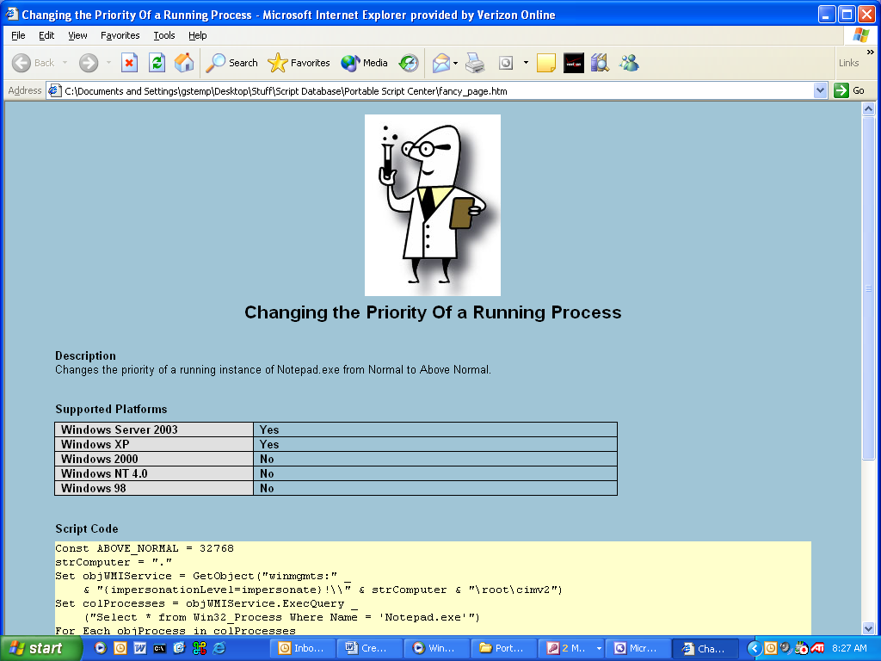

Well, OK: hopefully yours will look a little better. But at least you can change the pages if you so desire.

Tip. If you want to create a really fancy page, you might consider designing the page in an HTML editor (like FrontPage) and then copying the HTML code out of there. Say you get HTML code similar to this:

<p style="margin-left: 0.5in; margin-right: 0.5in; margin-top: 0in; margin-bottom: 0pt">

Paste that code directly into your script, and then modify it to look like this:

<p style="margin-left: 0.5in; margin-right: 0.5in; margin-top: 0in; margin-bottom: 0pt">

All we’re doing is slapping NewFile.WriteLine " onto the beginning and " onto the end. Thus:

NewFile.WriteLine "<p style="margin-left: 0.5in; margin-right: 0.5in; margin-top: 0in; margin-bottom: 0pt">"

We then use chr(34) to insert double quote marks as needed, and we end up with this:

NewFile.WriteLine "<p style=" & chr(34) & "margin-left: 0.5in; margin-right: 0.5in; margin-top: 0in; margin-bottom: 0pt" & chr(34) & ">"

Good point: or you could just leave the pages as-is.

- You might also want to change both the text that appears in the title bar of your finished .chm file (by default, that’s The Portable Script Center) as well as the file name of the .chm file (by default, script_center.chm). If you’re not real keen on either of those options, then edit these two lines in HTML_File_List_HHP_Maker.vbs:

objFile.WriteLine "Compiled file=script_center.chm"
objFile.WriteLine "Title=The Portable Script Center"

Oh, and open up HTML_Table_of_Contents_Maker.vbs and search for this line of code:

objFile.WriteLine " <param name=" & chr(34) & "Name" & chr(34) & " value=" & chr(34) & "The Portable Script Center" & chr(34) & ">"

When you find it, change The Portable Script Center to whatever you like better.

Creating and Compiling the Actual HTML Help File

As soon as you have all the preliminaries out of the way, creating and compiling a help file is remarkably quick and remarkably easy (the whole thing will take only a few minutes). Start by carrying out these steps:

- Run the script HTML_FolderMaker.vbs to create the folders where the HTML pages will be stored.
- Run the script HTML_Page_Maker.vbs to create the actual HTML pages.
- Run the script HTML_File_List_HHP_Maker.vbs to create the configuration file for the HTML Help project.
- Run the script HTML_Table_of_Contents_Maker.vbs to create the Table of Contents for the help file.

When these four steps are done, you’ll have all the pieces you need to create an HTML Help file; all that’s left to do is compile the actual .chm file. If you want, you can do this right from the command line using the file hhc.exe (most likely you’ll find that file in C:\Program Files\HTML Help Workshop). Just type hhc.exe followed by the path to the .hhp configuration file. Assuming you haven’t changed any of the default values, you’d type this:

hhc.exe c:\html\script_center.hhp

Most likely you’ll see a flurry of warnings regarding empty HTML tags; don’t worry about those. When the compile is done, you’ll have a new file (by default, named script_center.chm) ready to use.

And, yes, you could also open the .hhp file in HTML Help Workshop, and compile the .chm file from there; you could also use HTML Help Workshop to modify the project further. But you’re on your own for that.

So does this actually work? You bet it does; here’s a sample .chm file we created (following our own instructions) that has a different default page and contains only scripts that run on Windows NT 4.0 (notice that the Table of Contents doesn’t include categories like Virtual Server):

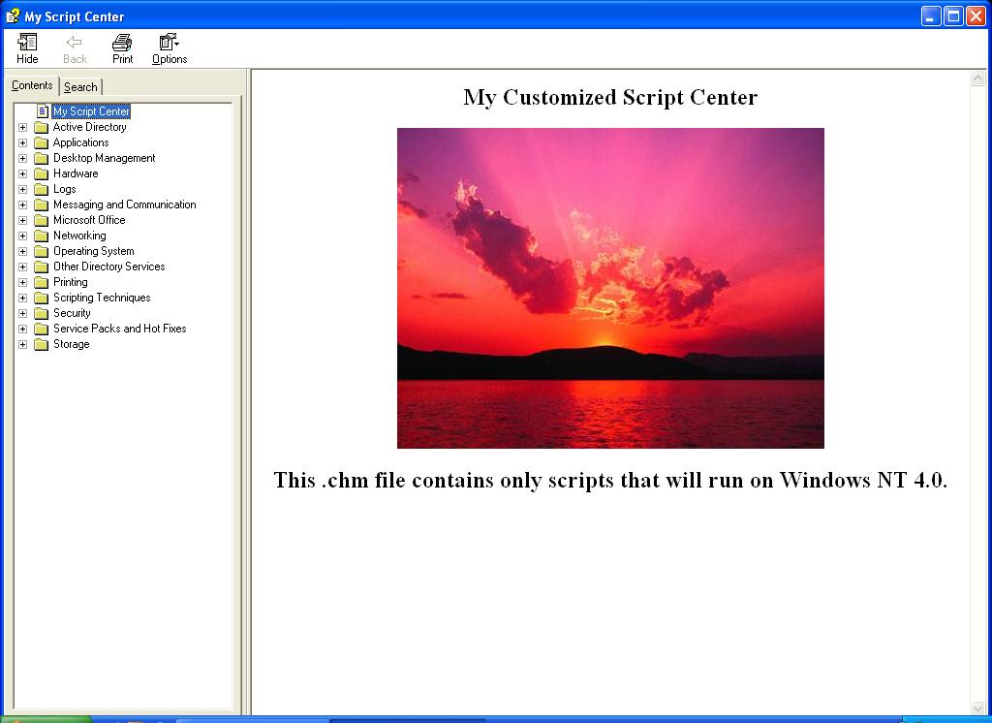

I know, it’s hard to believe; even we didn’t expect something like this to work. But it does.

